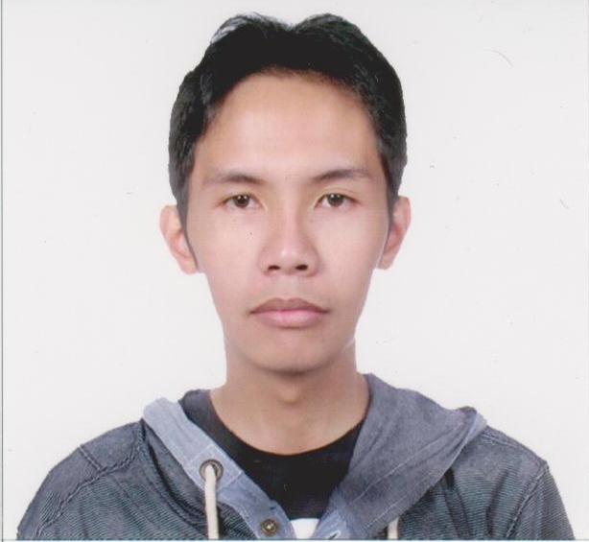
Jexter Dean Buenaventura
09277070478
jexterdeanbuenaventura@gmail.com
- Extensive experience and training in a Fortune 500 company (Texas Instruments).
- A results-driven programmer experienced at coding, designing, developing and maintaining enterprise systems, websites and databases.
- Competent in various technologies including Java, Oracle, MySQL, HTML, CSS, JQuery/ JavaScript and PHP.

Technology Summary
Languages/  Programming | Systems | Networking | Database | Frameworks
- Java  - JSP  - J2EE  - PHP  - SQL  - HTML  - JSON  - CSS  - Javascript  - JQuery  - Bash Scripting | - Windows  - Linux(Debian, OpenSuSe) | - SSH  - SFTP  - FTP  - Telnet | - Oracle EE 8i/9i/10g/11g  - MySQL | - FFW  - Wordpress  - Joomla

Professional Experience
Texas Instruments Baguio City, Philippines
Java Programmer, June 2009 – December 2012
Developed and supported projects for Texas Instruments Philippines (TIPI) and sub contractual companies as a Java programmer.
Under TI Apprenticeship  September 2010 – February 2011 | Under Ace Star Solutions  June 2009 – June 2010  March 2011 – December 2011 | Under Raj Tech  February 2012 - December 2012
Finished the JSP projects on time with little to no supervision other than when requirements were discussed and daily reports were needed. | Finished some enhancements on critical JSP projects that involved TIPI’s assembly operations and managerial sites. Worked with senior programmers and learned new technologies and business logic. | Initialized a key JSP project for parsing complex computations for Texas Instrument’s client (Amkor) to let them know how many chips are being lost during shipping. Finished the project on time and prompted the employees of Texas Instruments to proceed with Phase 2.
Employed new technologies at that time (JQuery, Apache POI) instead of using old technologies for the reports. | Maintained a lot of old support JSP projects that were critical. Little to no problems was encountered during maintenance. | Mentored new programmers to the Texas Instruments Framework called FFW and taught various technologies and supporting on their first JSP projects.

Syner-G Outsourcing Baguio City, Philippines
PHP Programmer, January 2013 – January 2014
Developed and maintained their Linux Servers, PHP based Reports and MySQL based Databases as well as maximized leads (list of phone numbers bought by the company) through lead recycling/harvesting using PHP and MySQL.
Key Achievements:
- Restored and repaired problems in Linux Servers due to neglect. Rebuilt Dialers while maintaining and backing up all sensitive/relevant data. All Servers now run with little to no problem.
- Built PHP web-based reports to automate manual reports. Improved report generation for all accounts in the company.
- Saved and secured Linux Servers from a hack attack that cost the company $17,000 worth of leads. Used Key based authentication on the servers and installed a firewall called Shorewall to block all unauthorized connections from the outside.
Stable Apps Taguig City, Philippines
PHP Programmer, March 2014 – June 2014
Developed new modules and maintained old modules on the website Lifehouse. Used the Yii Framework (A PHP-based Framework) and conducted Unit Tests to oversee overall stability of the website.
Key Achievements:
- Created a new module for synchronizing users in the database from an LDAP Database.
- Fixed various bugs on the old modules and improved overall site performance

Other Employments
Freelance work Singapore & Canada
PHP Programmer, July 2014 – June 2015
Developed various php projects for clients in Singapore and Canada. Frameworks used are Joomla and Wordpress.
Projects:
- E-commerce site for Filipinos (Singapore)
- Recruitment site (Canada)
- Stocks Web site (Canada)
- Financial Systems (Canada)

Education
Saint Louis University
Baguio City, Philippines
Bachelor of Science in Information Technology, April 2009

References
Reference | Company | Position | Phone Number | Email
Raldy Bogayong | Texas Instruments | IT Manager | +639175626063 | r-bogayong1@ti.com
Noel Yasay | SynerG Outsourcing | General Manager | +639337202486 | Knol2001@yahoo.com
Rachel Julian | RAJ Technologies | IT Manager | +639178148954 | cheng@ti.com

